The First-Time Home Buyer Incentive is a shared-equity mortgage with the Government of Canada. It offers:
- 5% or 10% for a first-time buyer’s purchase of a newly constructed home
- 5% for a first-time buyer’s purchase of a resale (existing) home
- 5% for a first-time buyer’s purchase of a new or resale mobile/manufactured home
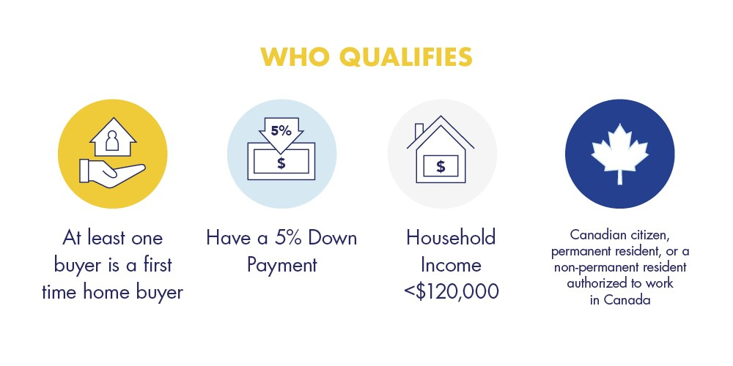
The Incentive’s shared-equity mortgage is one where the government has a shared investment in the home. As a result, the government shares in both the upside and downside of the property value.
By obtaining the Incentive, the borrower may not have to save as much of a down payment to be able to afford the payments associated with the mortgage. The effect of the larger down payment is a smaller mortgage, and, ultimately, lower monthly costs.
The homebuyer will have to repay the Incentive based on the property’s fair market value at the time of repayment. If a homebuyer received a 5% Incentive, they would repay 5% of the home’s value at repayment. If a homebuyer received a 10% Incentive, they would repay 10% of the home’s value at repayment.
The homebuyer must repay the Incentive after 25 years, or when the property is sold, whichever comes first. The homebuyer can also repay the Incentive in full any time before, without a pre-payment penalty

